PRESS RELEASE FOLLOWING THE OFFICIAL BOOK LAUNCH OF:

“Izzy’s Magical Football Adventure”

The exciting new children’s book about a young girl playing Gaelic Football

About the book:
Izzy is a seven-year-old girl who lives in Ireland and loves all sport, especially Gaelic Football.

Izzy plays football with her brothers on a regular basis in their back garden and dreams of playing for her county in the All Ireland Ladies Football Final in Croke Park when she is older.

One day, Izzy puts on her great grandmother’s bracelet, which is made of old All Ireland medals that her great grandmother won a long time ago, and something unexpected and magical happens, which may make Izzy’s Croke Park dream a reality sooner than she expected…………….

This book is aimed at readers from age seven onwards starting to read independently. It is based around the themes of girls in sport, encouraging girls to play sport and girl’s ability to play sport at a high level, while also having a fun magical theme. It could also be read to a younger child.
It is county neutral, but there is also a Cork, Kerry and Dublin edition.

About the author:

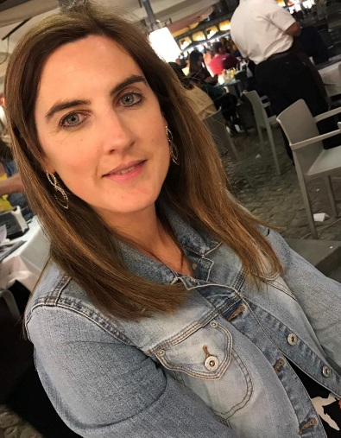

Emma Larkin lives in Kerry in Ireland with her husband and four children. She is the founder of “Emma Larkin Books” and “Rebel in Kerry Press”. Izzy’s Magical Football Adventure is her first book.
Emma’s inspiration to write her first book was her grandmother, Maureen Hennebry, née Cashman. She was on the Cork camogie team which won the All-Ireland Camogie Championship three times in row between 1939 and 1941. Emma hopes that all young girls and boys who read this book will enjoy it and will be inspired to play not only Gaelic football, but all sports.

emmalarkinbooks.com
emma@emmalarkinbooks.com
facebook.com/emmalarkinbooks/
twitter @emmalarkinbooks
Instagram.com @emmalarkinbooks/

Official Launch:
The official launch of “Izzy’s Magical Football Adventure” took place in the wonderful surroundings of the Kerry Writer’s Museum in Listowel on Friday 22nd November. Billy Keane launched the book.
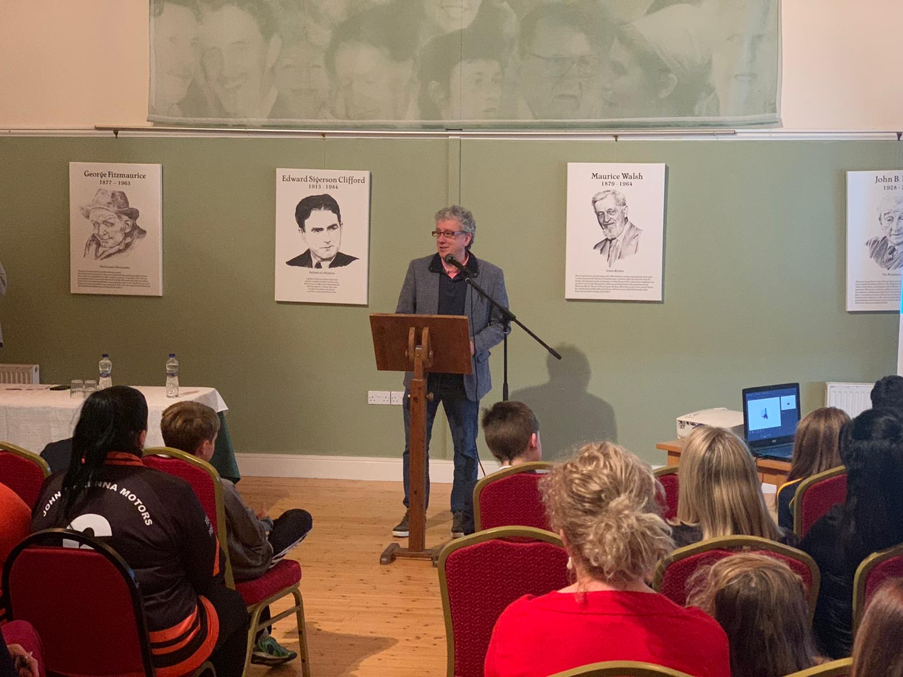
Billy Keane

Speakers on the night were Louise Galvin, Irish Rugby Sevens Players and former Kerry Ladies Footballer. Louise spoke passionately about her love of sport and how much it has given her and was an inspiration to the many young children present on the night. She is a fantastic role model for young girls. She stayed around after the speeches and chatted and signed books for lots of children present.
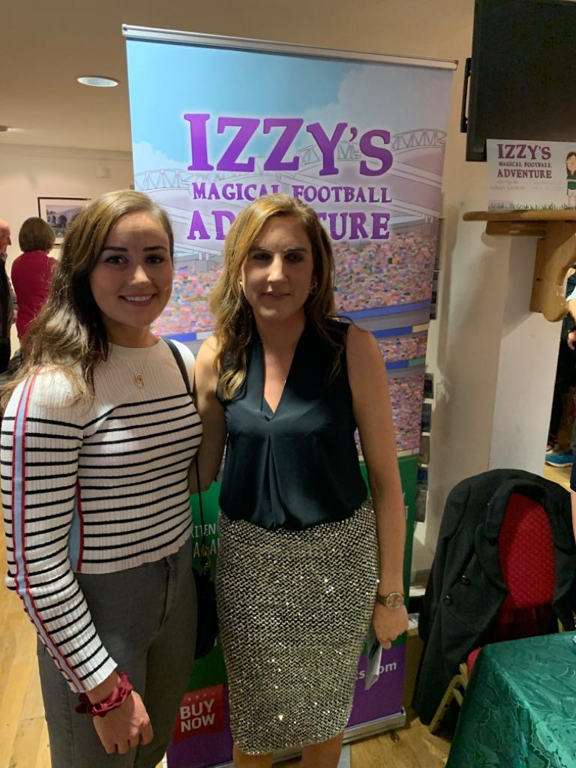
Louise Galvin and Emma Larkin
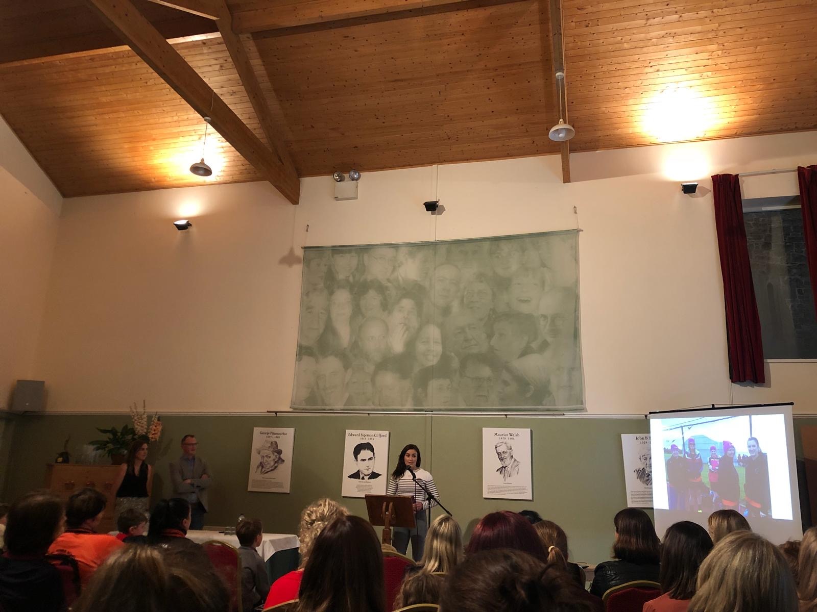
Louise Galvin Speaking
Our next speaker on the night was Ephie Fitzgerald, Cork Senior Ladies Football Manager, who was also inspirational in his belief and passion for ladies’ football, and he had great words of wisdom for the kids present also.
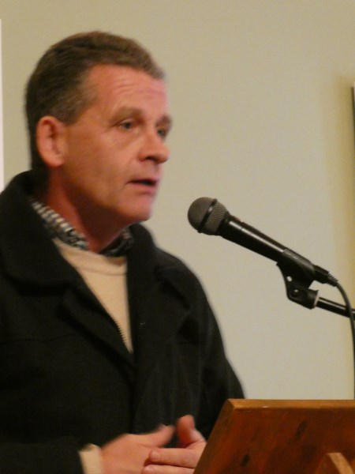
Ephie Fitzgerald, Cork Ladies Football Senior Team Manager

Our other speakers were Katherine O’Callaghan, Chairperson, Finuge/St. Senans Ladies Football Club, Paul Nugent, illustrator of the book, and Emma Larkin, Author.
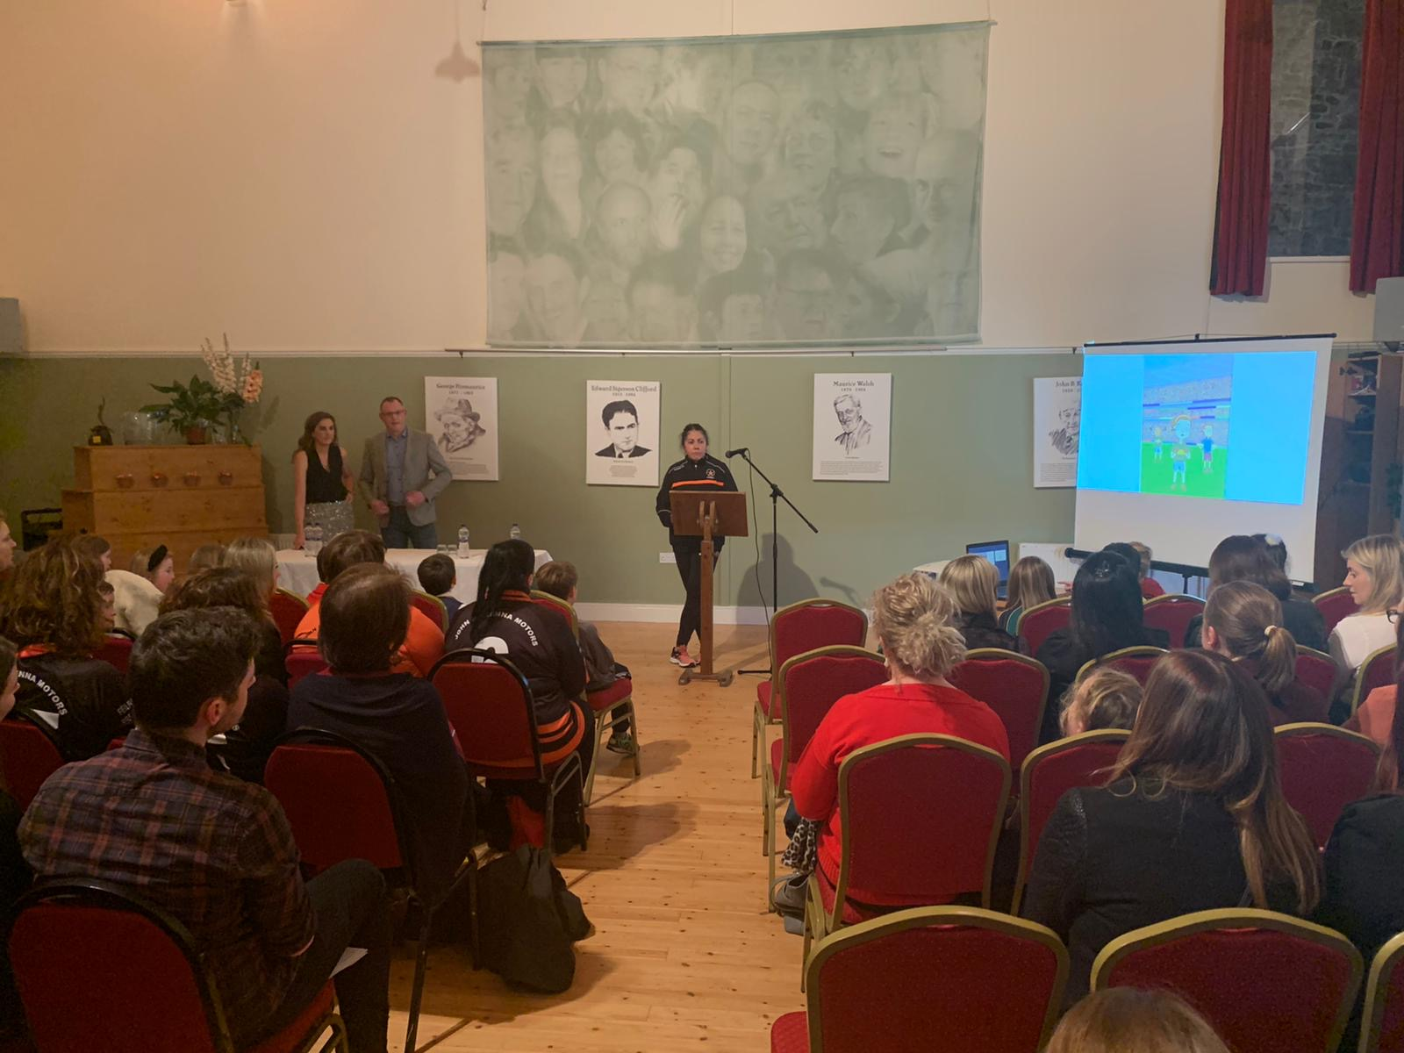
Katherine O’Callaghan, Chairperson, Finuge/St. Senans Ladies Football Club
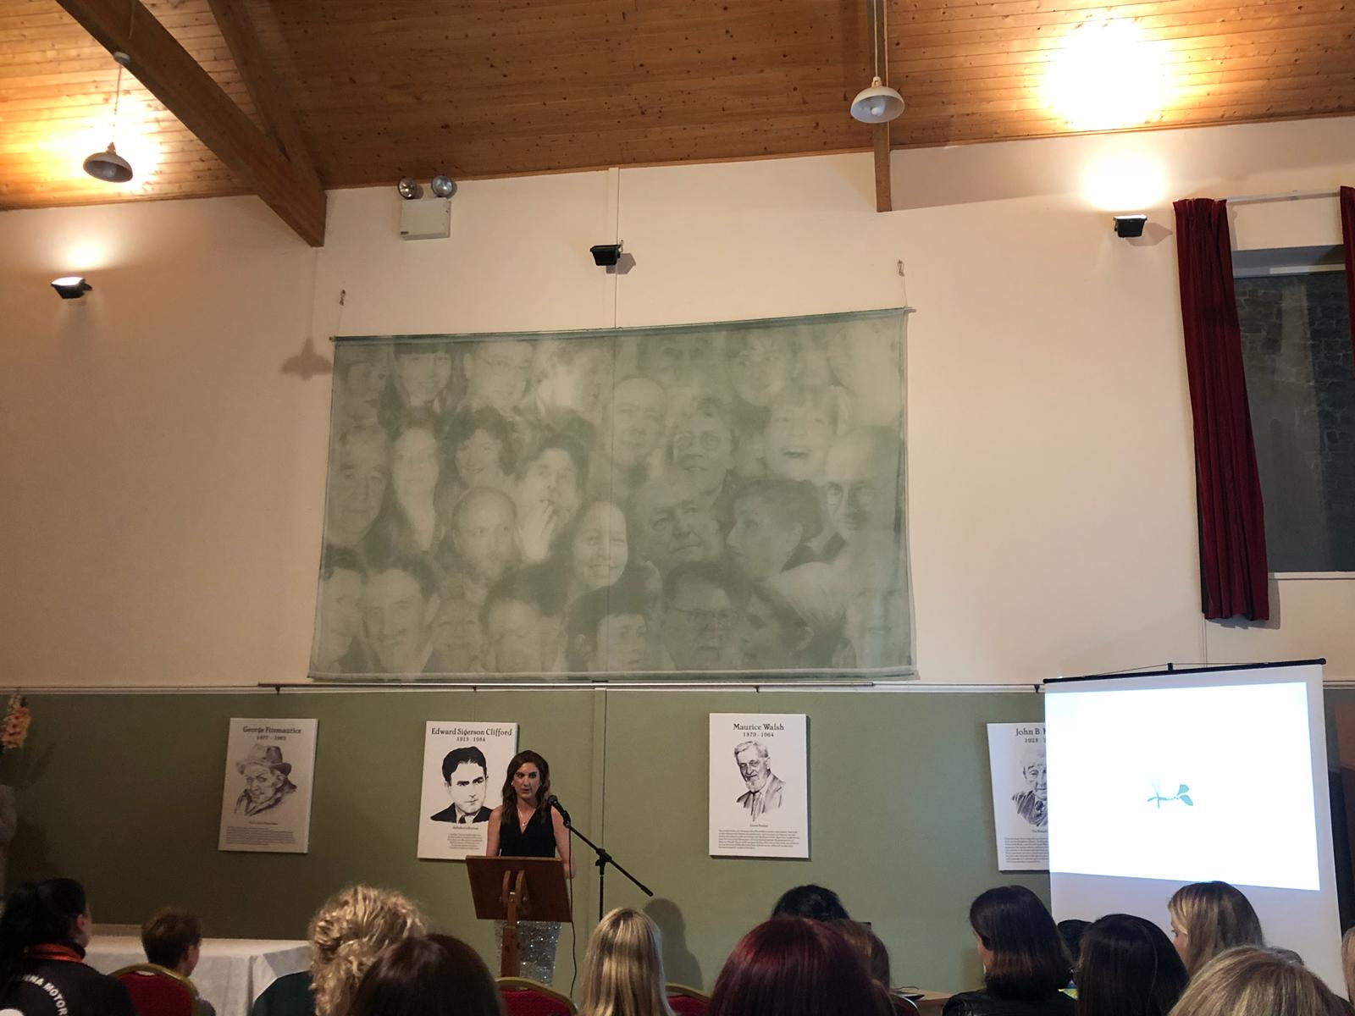
Emma Larkin, Author
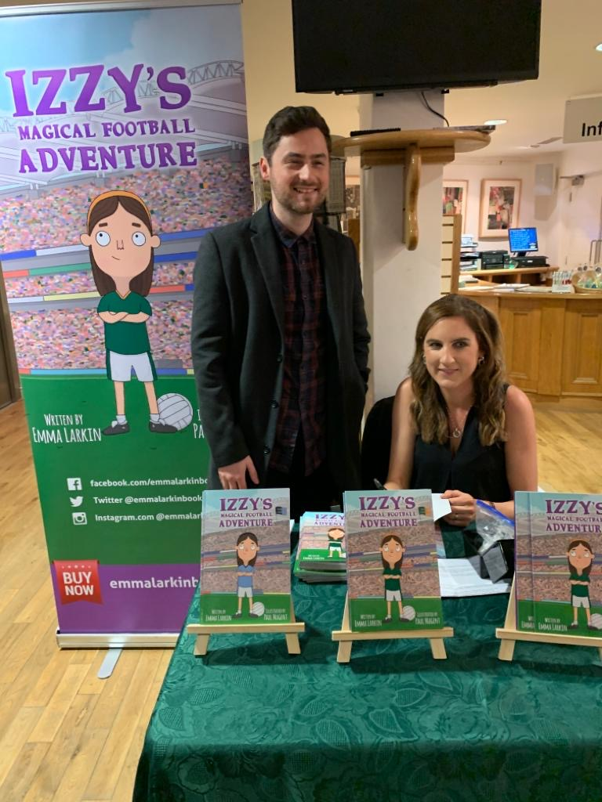
Paul Nugent and Emma Larkin
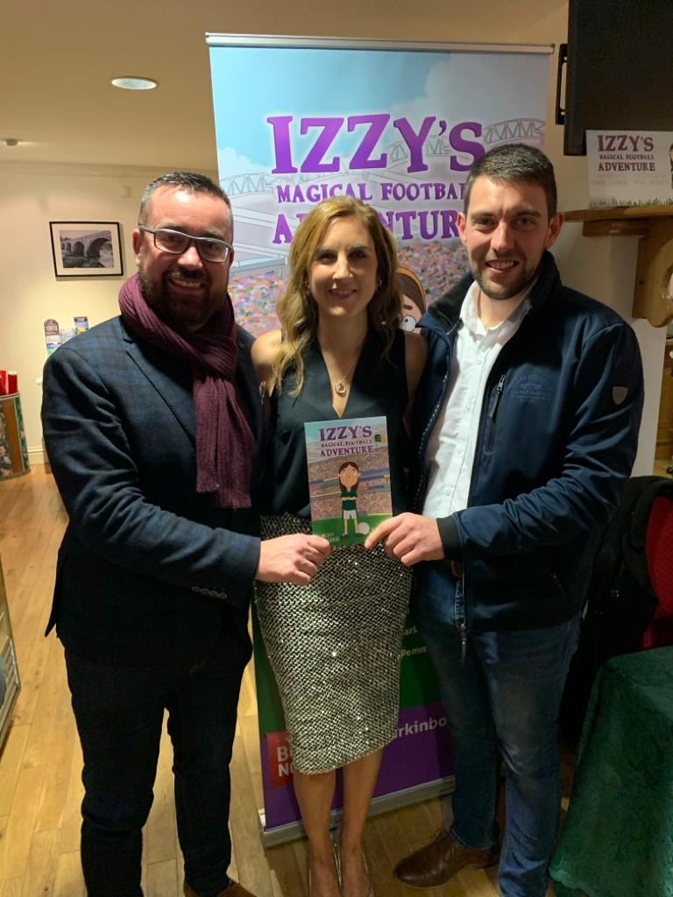
Seamus Mulvhill, Referee, Emma Larkin, Author and Eamon Moran, Referee
